125LB TOW-BEHIND SPREADER

ASSEMBLY AND OPERATION INSTRUCTION MANUAL

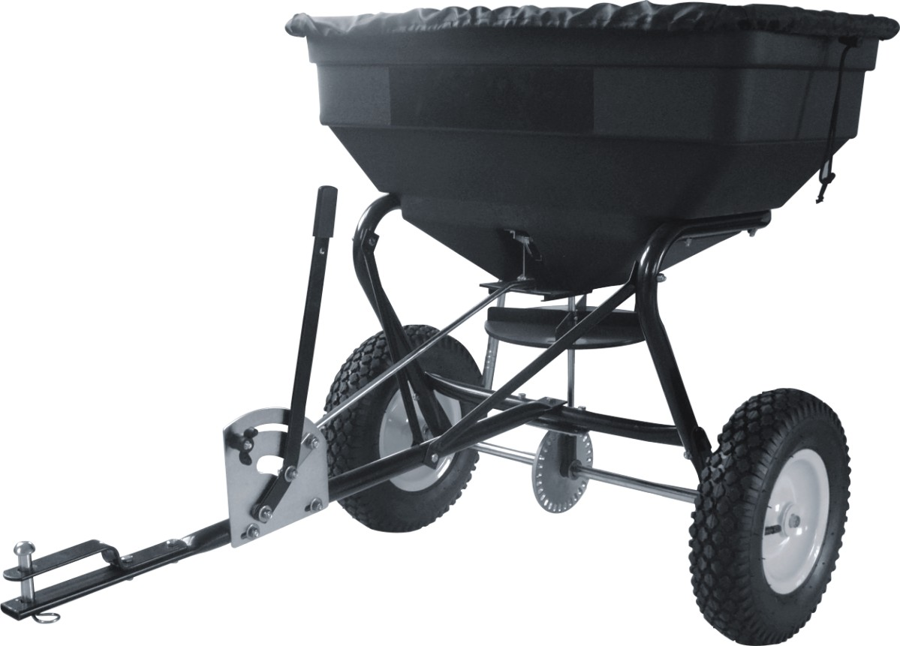

IMPORTANT INSTRUCTIONS
SPECIFICATION
Capacity: 125LB / 60L
Dimension of Hopper: 29-1/2in.x16-1/2in.x13-2/5in. (75x42x34cm)
Length of Tow Bar: 31-7/8in. (81cm)
Net Weight: 25.6lb/11.6kg
Overall Size: 41-1/2in.x29-1/2in.x29-1/2in. (105.5x75x75cm)
Wheel Diameter: 12in. (31cm)
Wheel Width: 3in. (8cm)
HELPFUL HINTS:
READ THE DIRECTIONS BEFORE ASSEMBLY
WHEN ALL ELSE FAILS, READ THE DIRECTIONS AGAIN

- Read the towing vehicle owners manual and towing vehicle safety rules. Know how to operate your tractor before using the tow-behind spreader.
- Read the chemical label instructions and cautions for handling and applying the chemicals purchased for spreading.
- Wear eye and hand protection when handling and when applying lawn or garden chemicals.
- Never operate tractor and spreader attachment without wearing substantial footwear, and do not allow anyone to ride or sit on spreader attachment frame.
- Never allow children to operate the tractor or spreader attachment, and do not allow adults to operate without proper instructions.
- Always begin with the transmission in first (low) gear and with the engine at low speed, and gradually increase speed as conditions permit.
- When towing spreader do not drive too close to a creek or ditch and be alert for holes and other hazards which could cause you to loose control of the spreader and tractor.
- Before operating vehicle on any grade (hill) refer to the safety rules in the vehicle owner’s manual concerning safe operation on slopes. Stay off steep slopes!
- If your spreader does not spread evenly, be sure the FRONT on the gear box points to the front of the spreader. The impeller must turn clockwise. Reversing the gear box will cause the impeller to turn counter clockwise. Clean the impeller plate after each use. Fertilizer stuck on the impeller blades will cause uneven spreading.
- Gears are permanently lubricated at the factory. Do not open the gear box or dirt may enter.

1. Remove and identify loose parts from carton and bag.
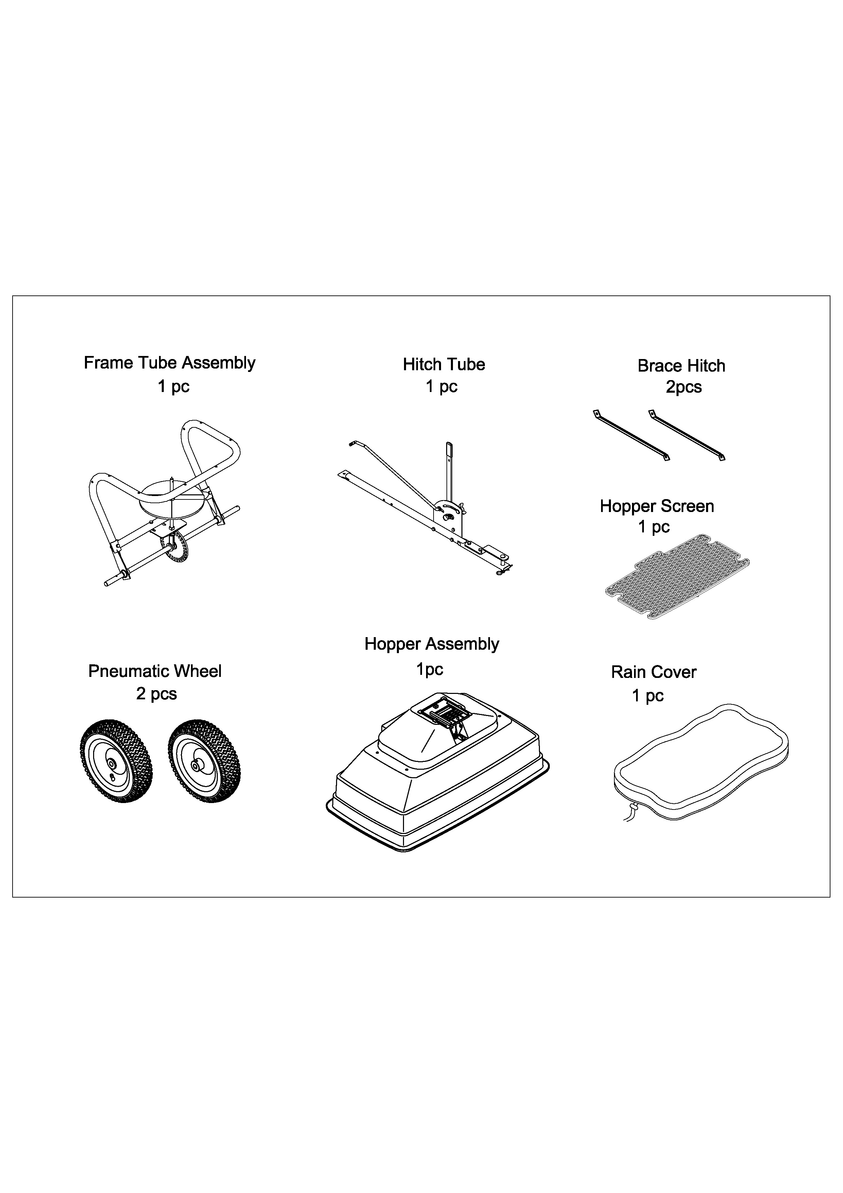
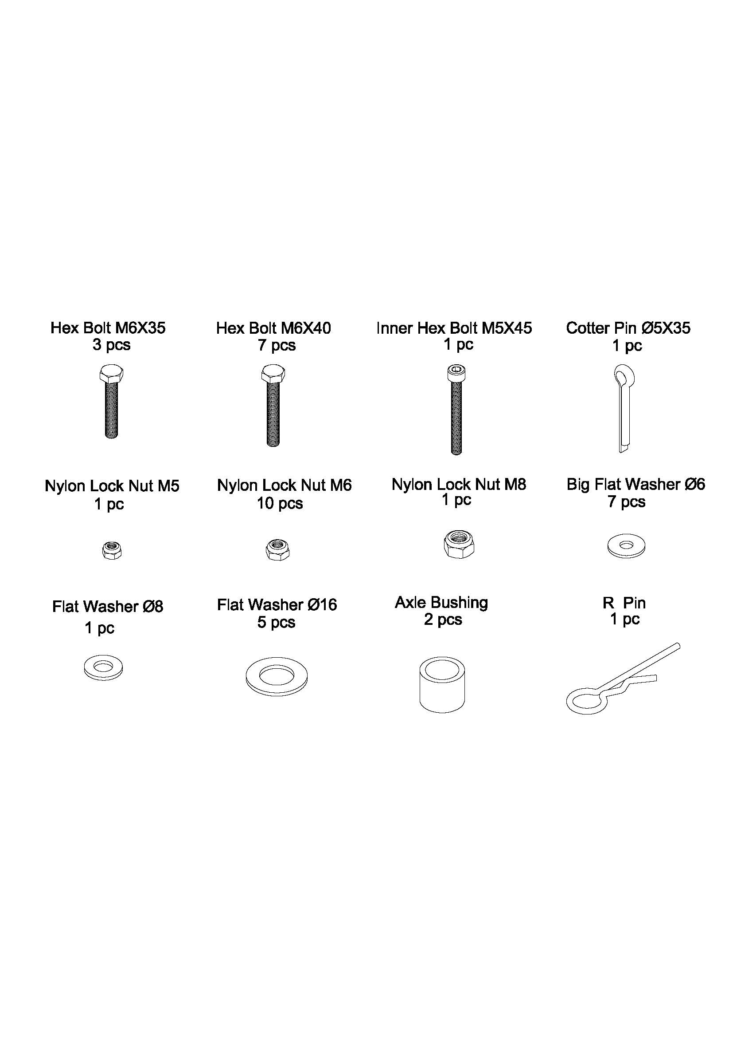
STEP 1: ASSEMBLE WHEEL

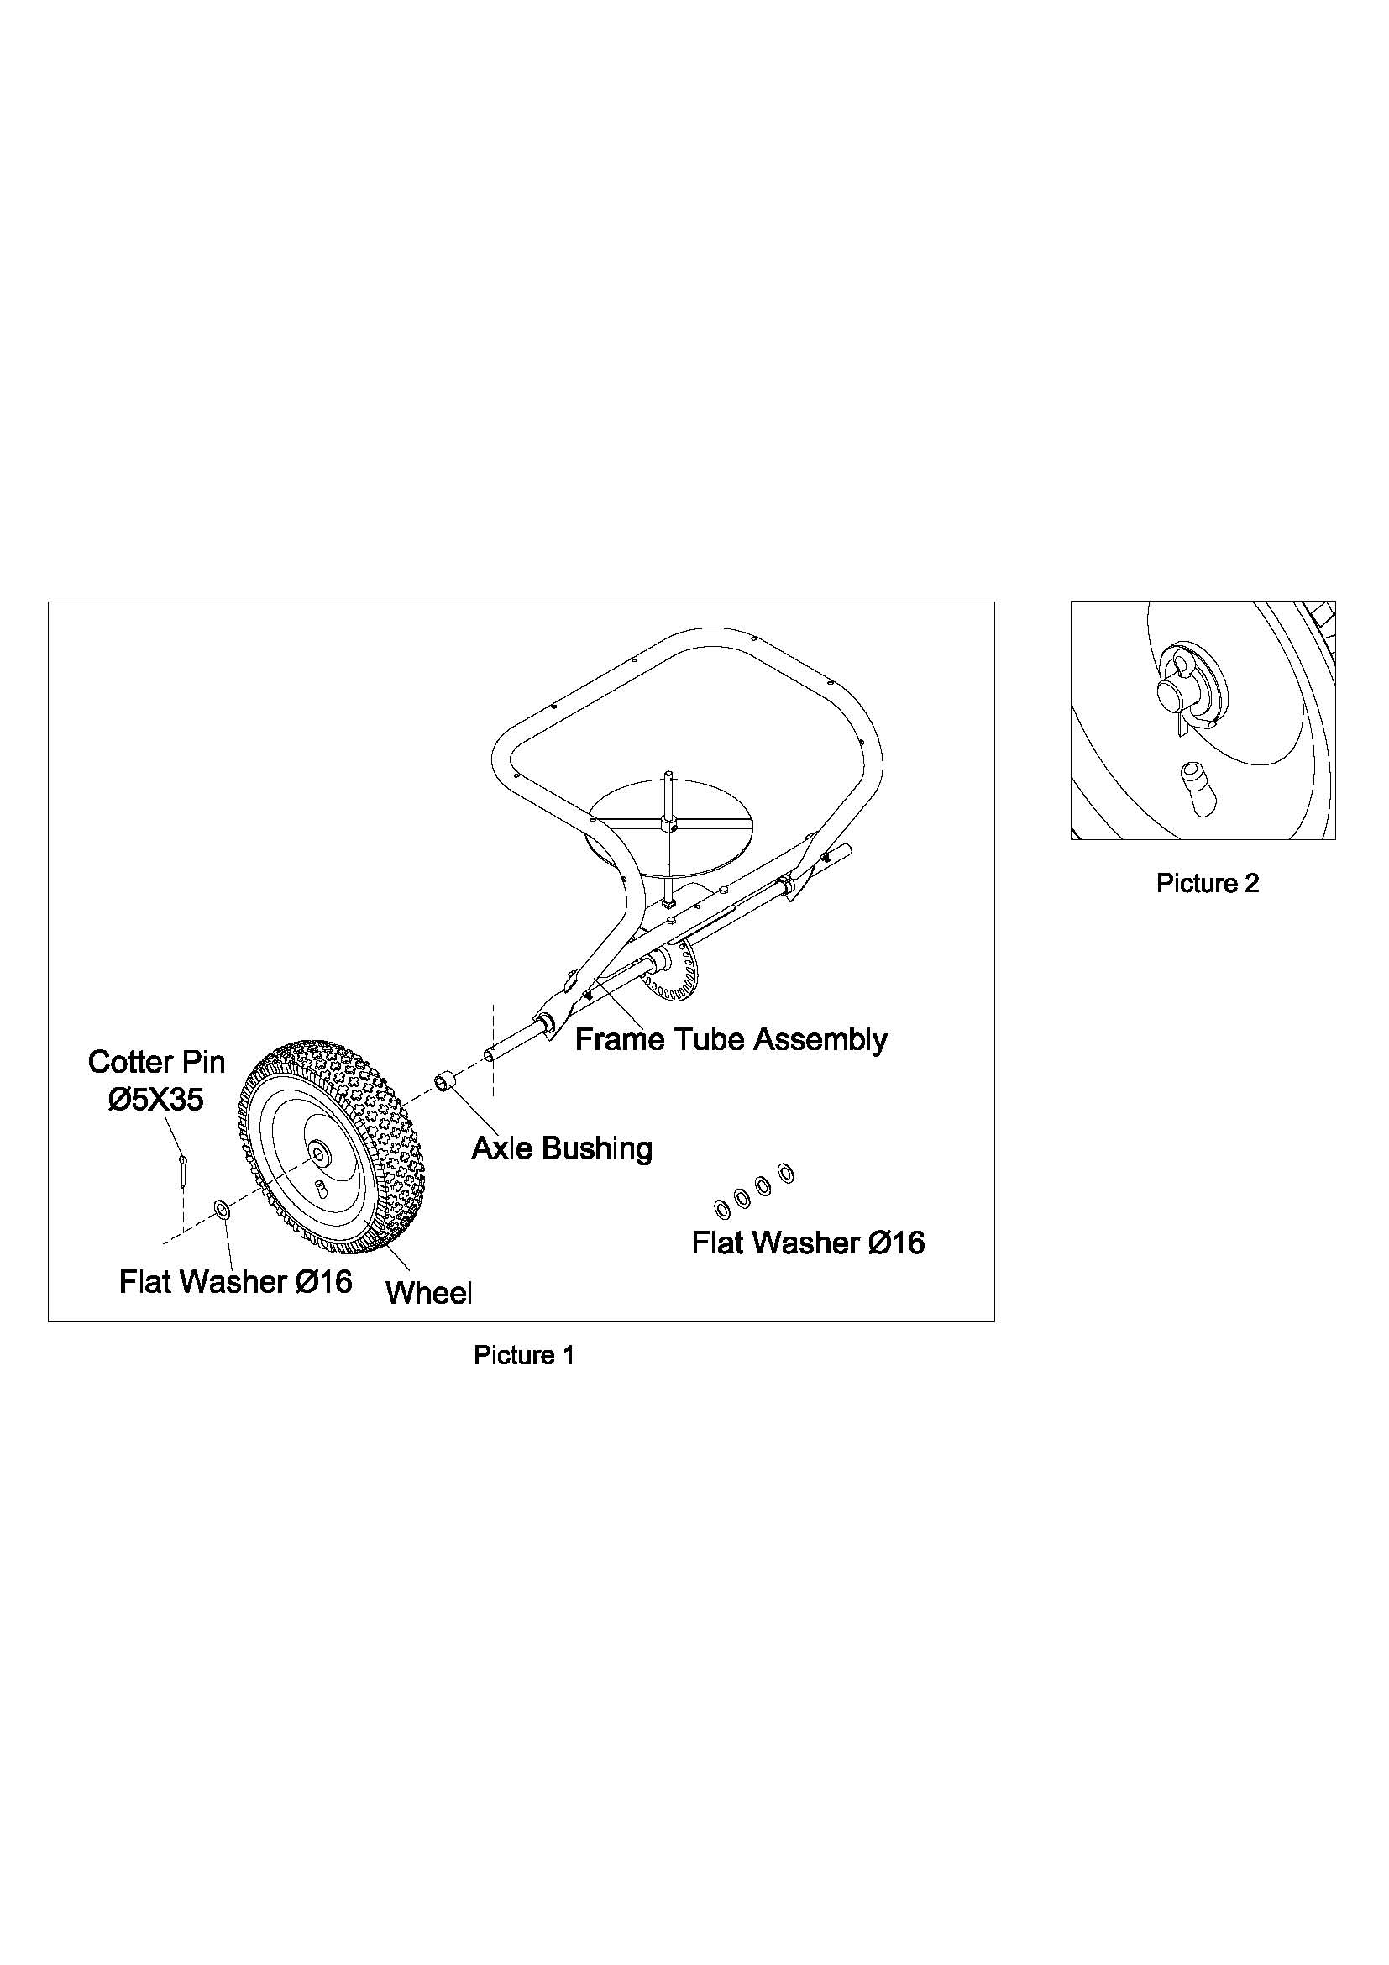
Assemble the wheel to the Frame Tube Assembly. Fix 1pc Axle Bushing to the wheel axle at one side of the frame tube, inert the wheel to the axle; fix the wheel with 1pc Flat Washer Ø16 and 1pc Cotter Pin Ø5x35. (There has extra 4pcs of Flat Washer Ø16 for adjusting the space between wheel and axle bushing.) See picture 1 & 2.

STEP 2: ASSEMBLE WHEEL

Assemble another wheel on the other side of the frame tube assembly. Insert 1pc Axle Bushing before assemble the wheel to the axle. Fix the wheel by using 1pc Inner Hex Bolt M5x45 and 1pc Nylon Lock Nut M5. Make sure the hole on the wheel will be aligning at the hole on the wheel axle, and then secure the wheel by inserting the Inner Hex Bolt to the holes. Please refer Picture 3 for assembly and Picture 4 for the position of inner hex bolt.
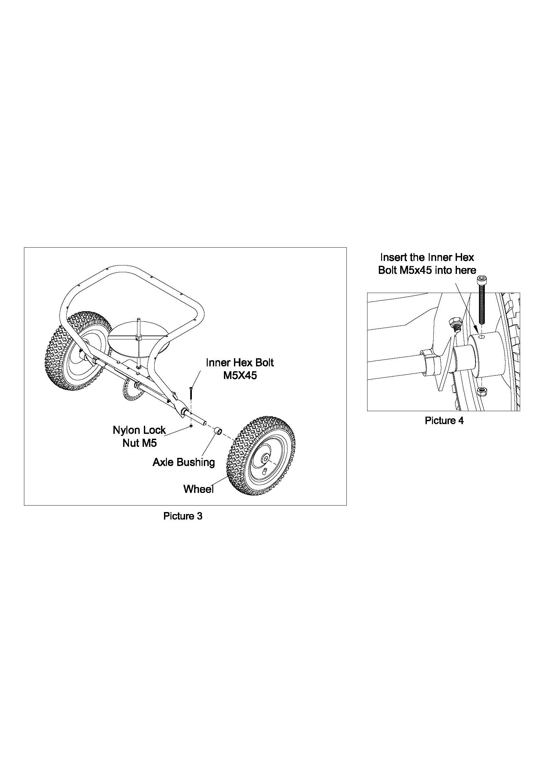

STEP 3: ASSEMBLE THE HITCH TUBE
Assemble the hitch tube to the middle of the frame tube assembly by using 1 pc Hex Bolt M6x40. Secure the bolt with 1 pc Big Flat Washer Ø6 and 1 pc Nylon Lock Nut M6. See picture 5 & 6.
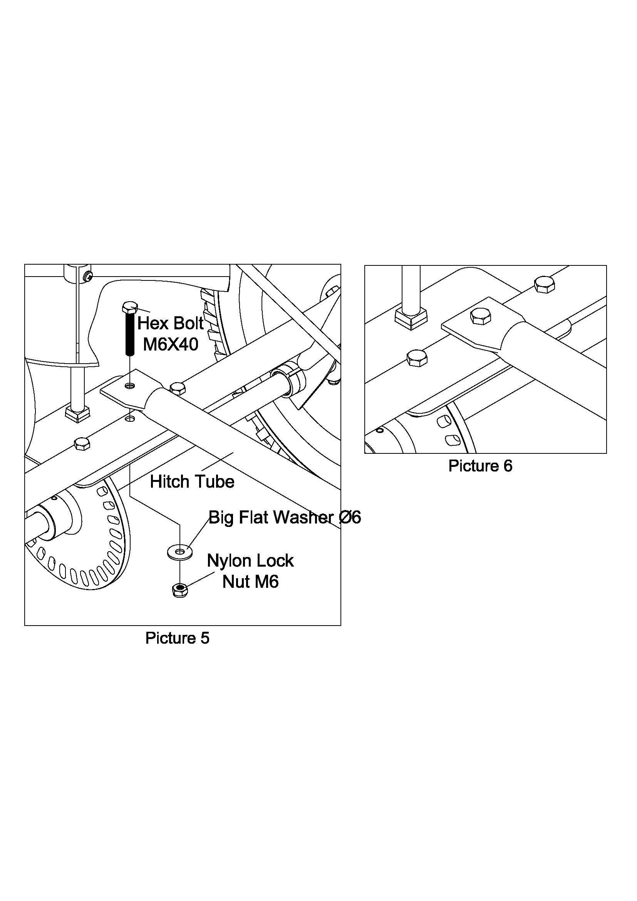

STEP 4: ASSEMBLE THE BRACE HITCH
Assemble one end of Brace Hitches to the middle of the Hitch Tube, fix with 1pc Hex Bolt M6x35 and 1 pc Nylon Lock Nut M6. See picture 7 & 8.

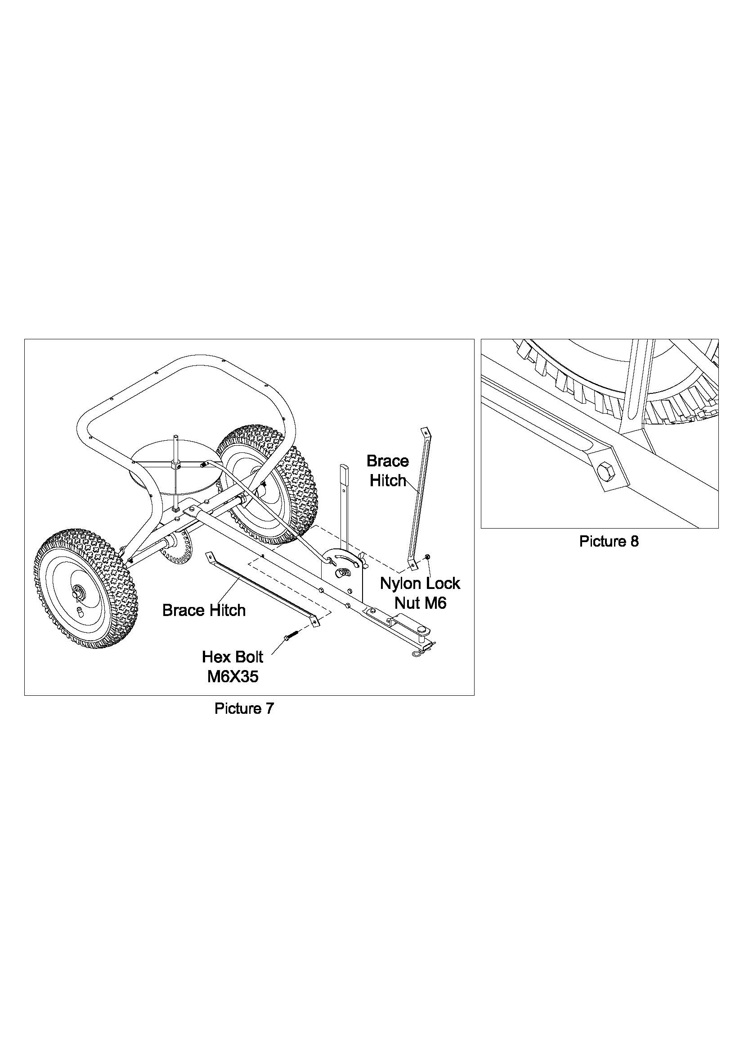

STEP 5: ASSEMBLE THE BRACE HITCH
Assemble another end of the Brace Hitches to the inside of Frame Tube Assembly (Hopper Frame) by using 1pc Hex Bolt M6x35 and 1 pc Nylon Lock Nut M6
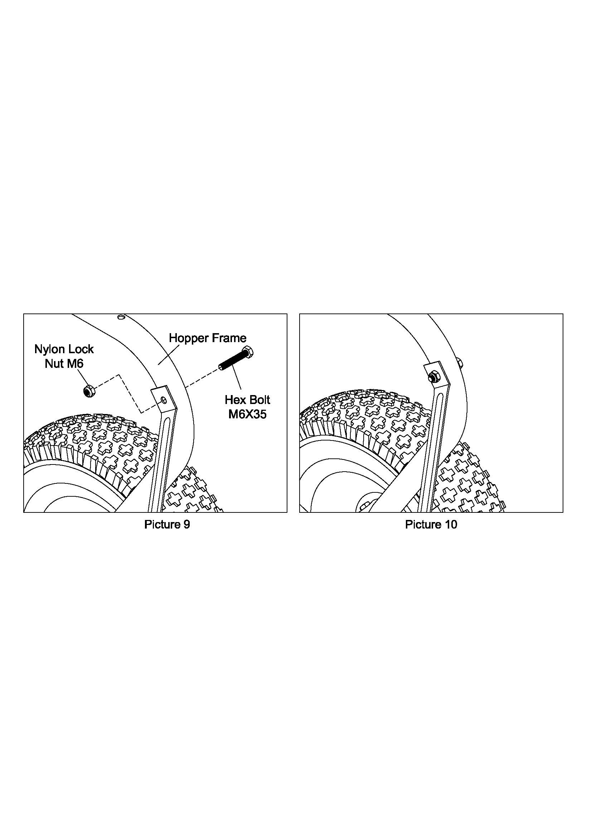

STEP 6: ASSEMBLE HOPPER
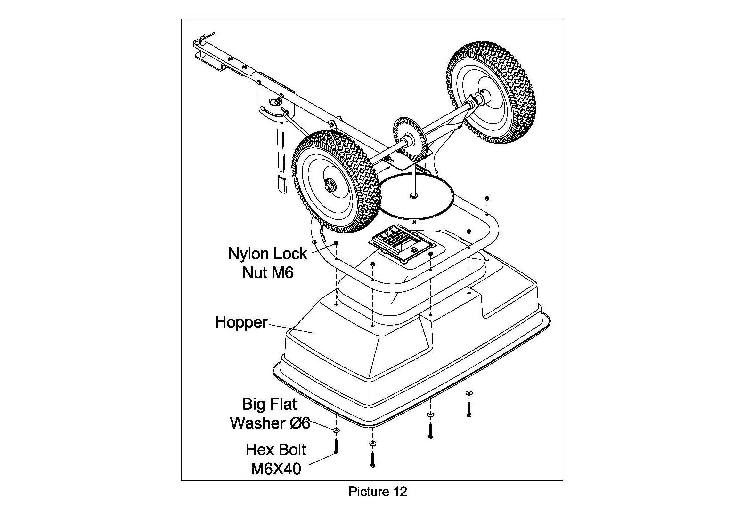
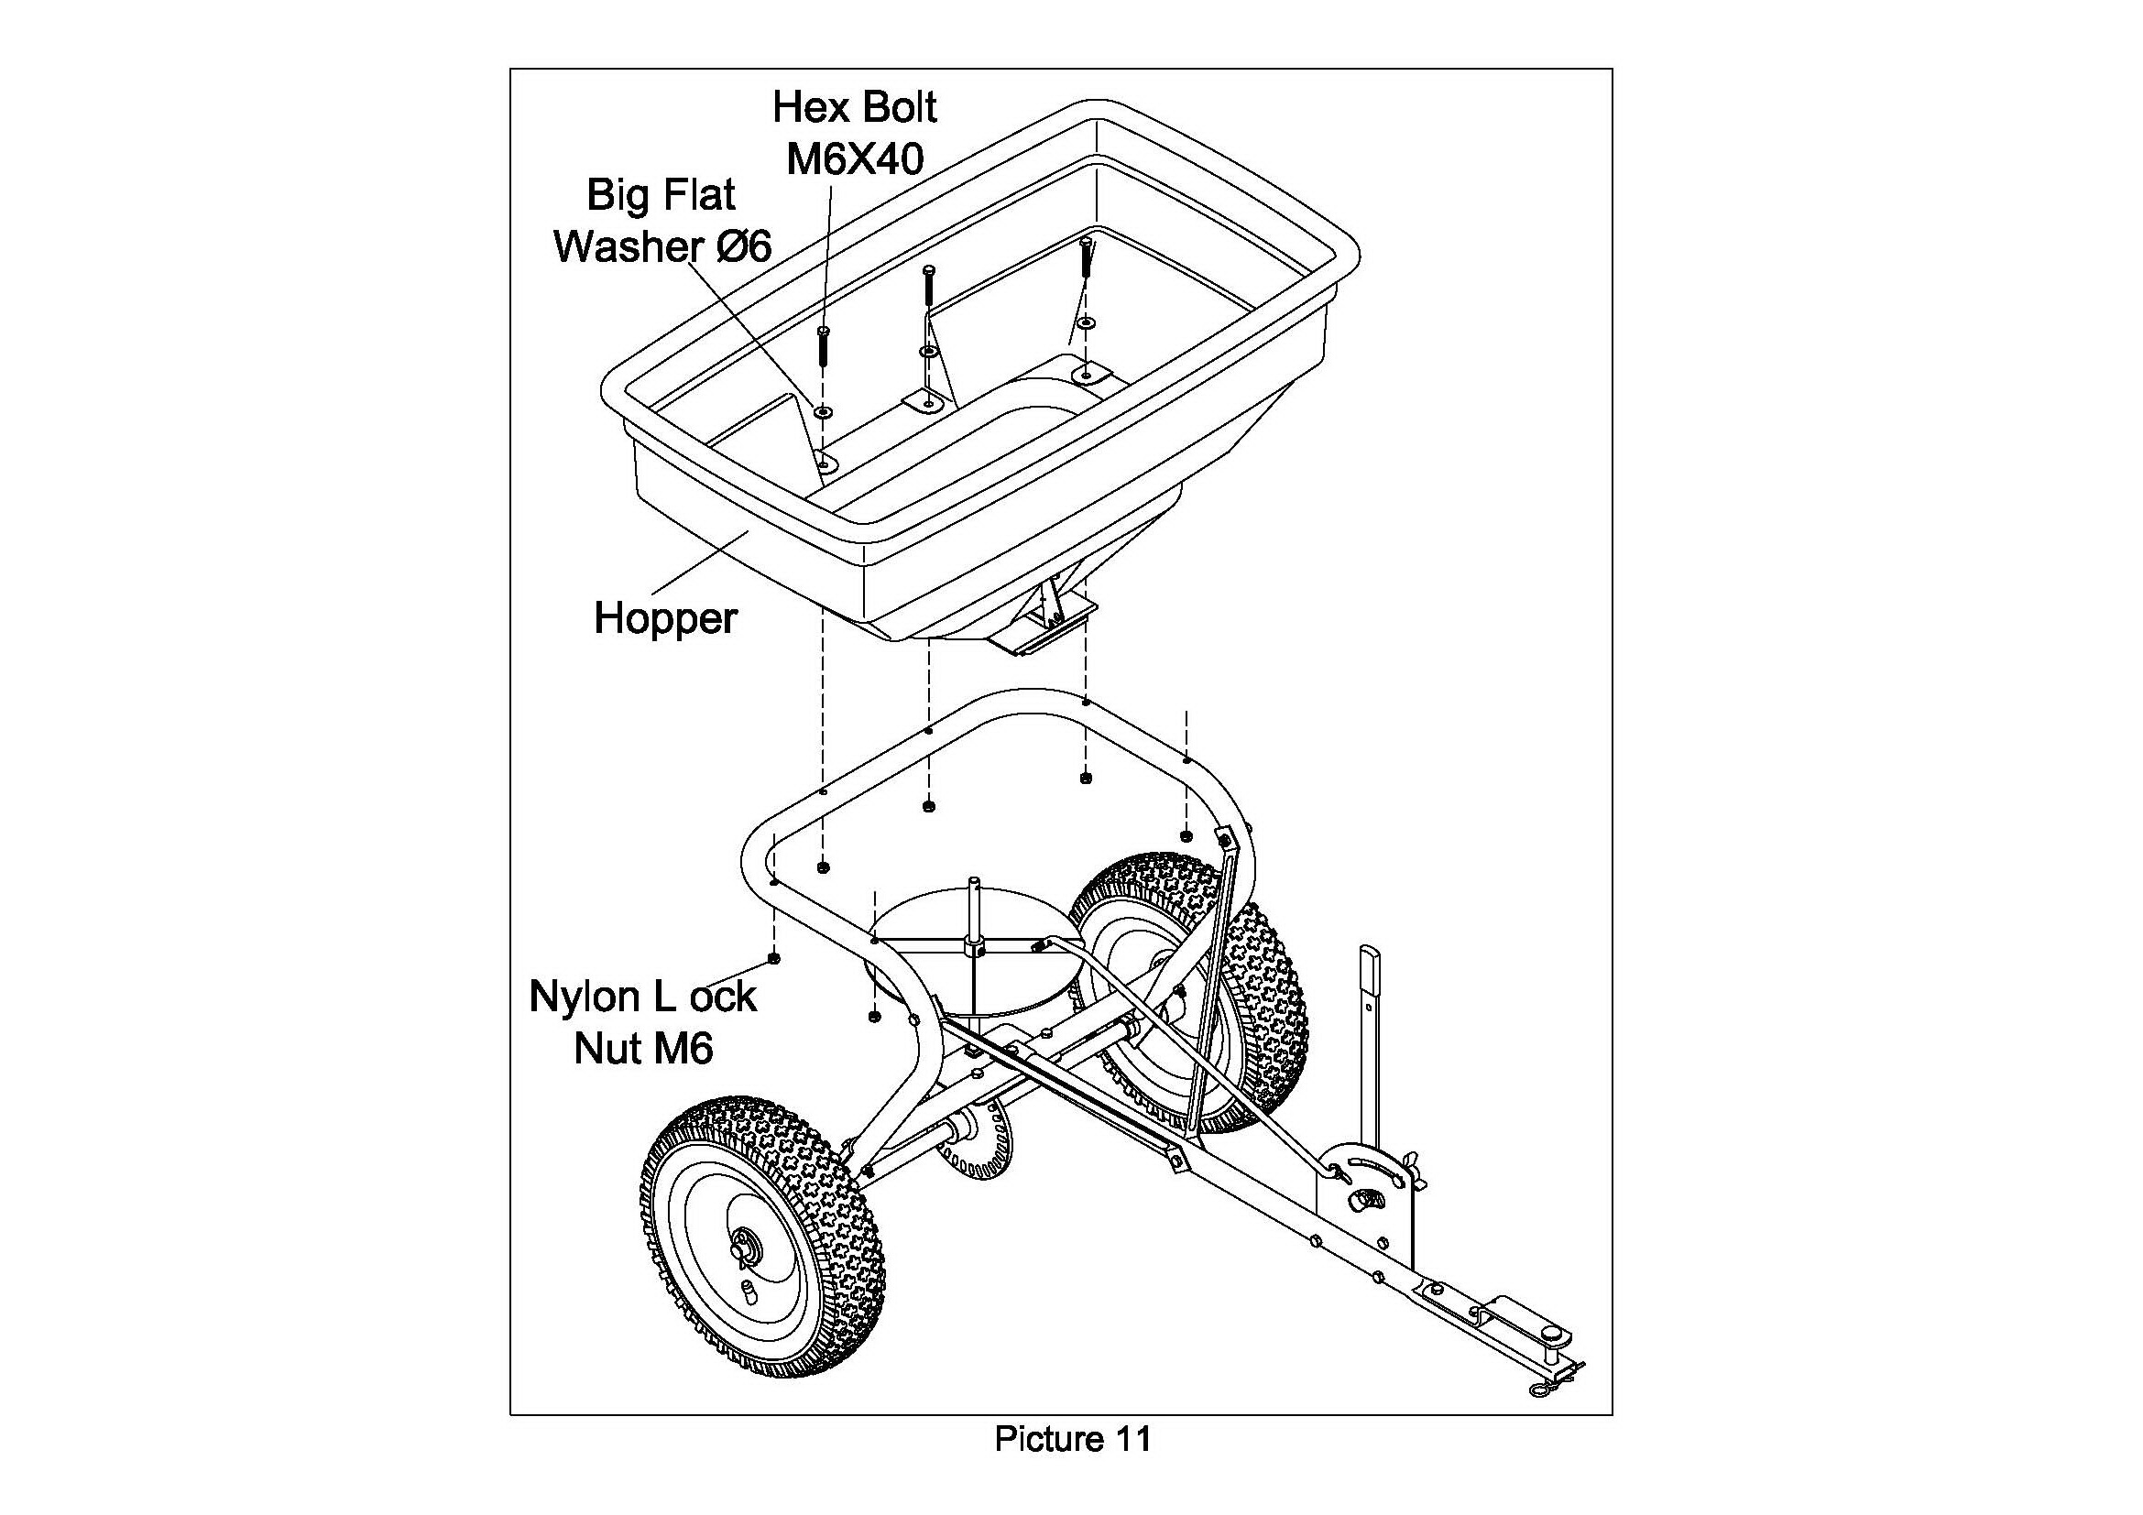
Assemble the hopper to the frame tube assembly, make sure the six holes on hopper are align at the holes on hopper frame, then fix the hopper with frame by using 6 sets of Hex Bolt M6x40, Big Flat Washer Ø6 and Nylon Lock Nut M6. See picture 11. If turn over the hopper, please see picture 12.

STEP 7: ASSEMBLE THE R PIN IN THE HOPPER

Assemble the R Pin to the hole of Swivel Axle in the hopper. See picture 13 & 14.
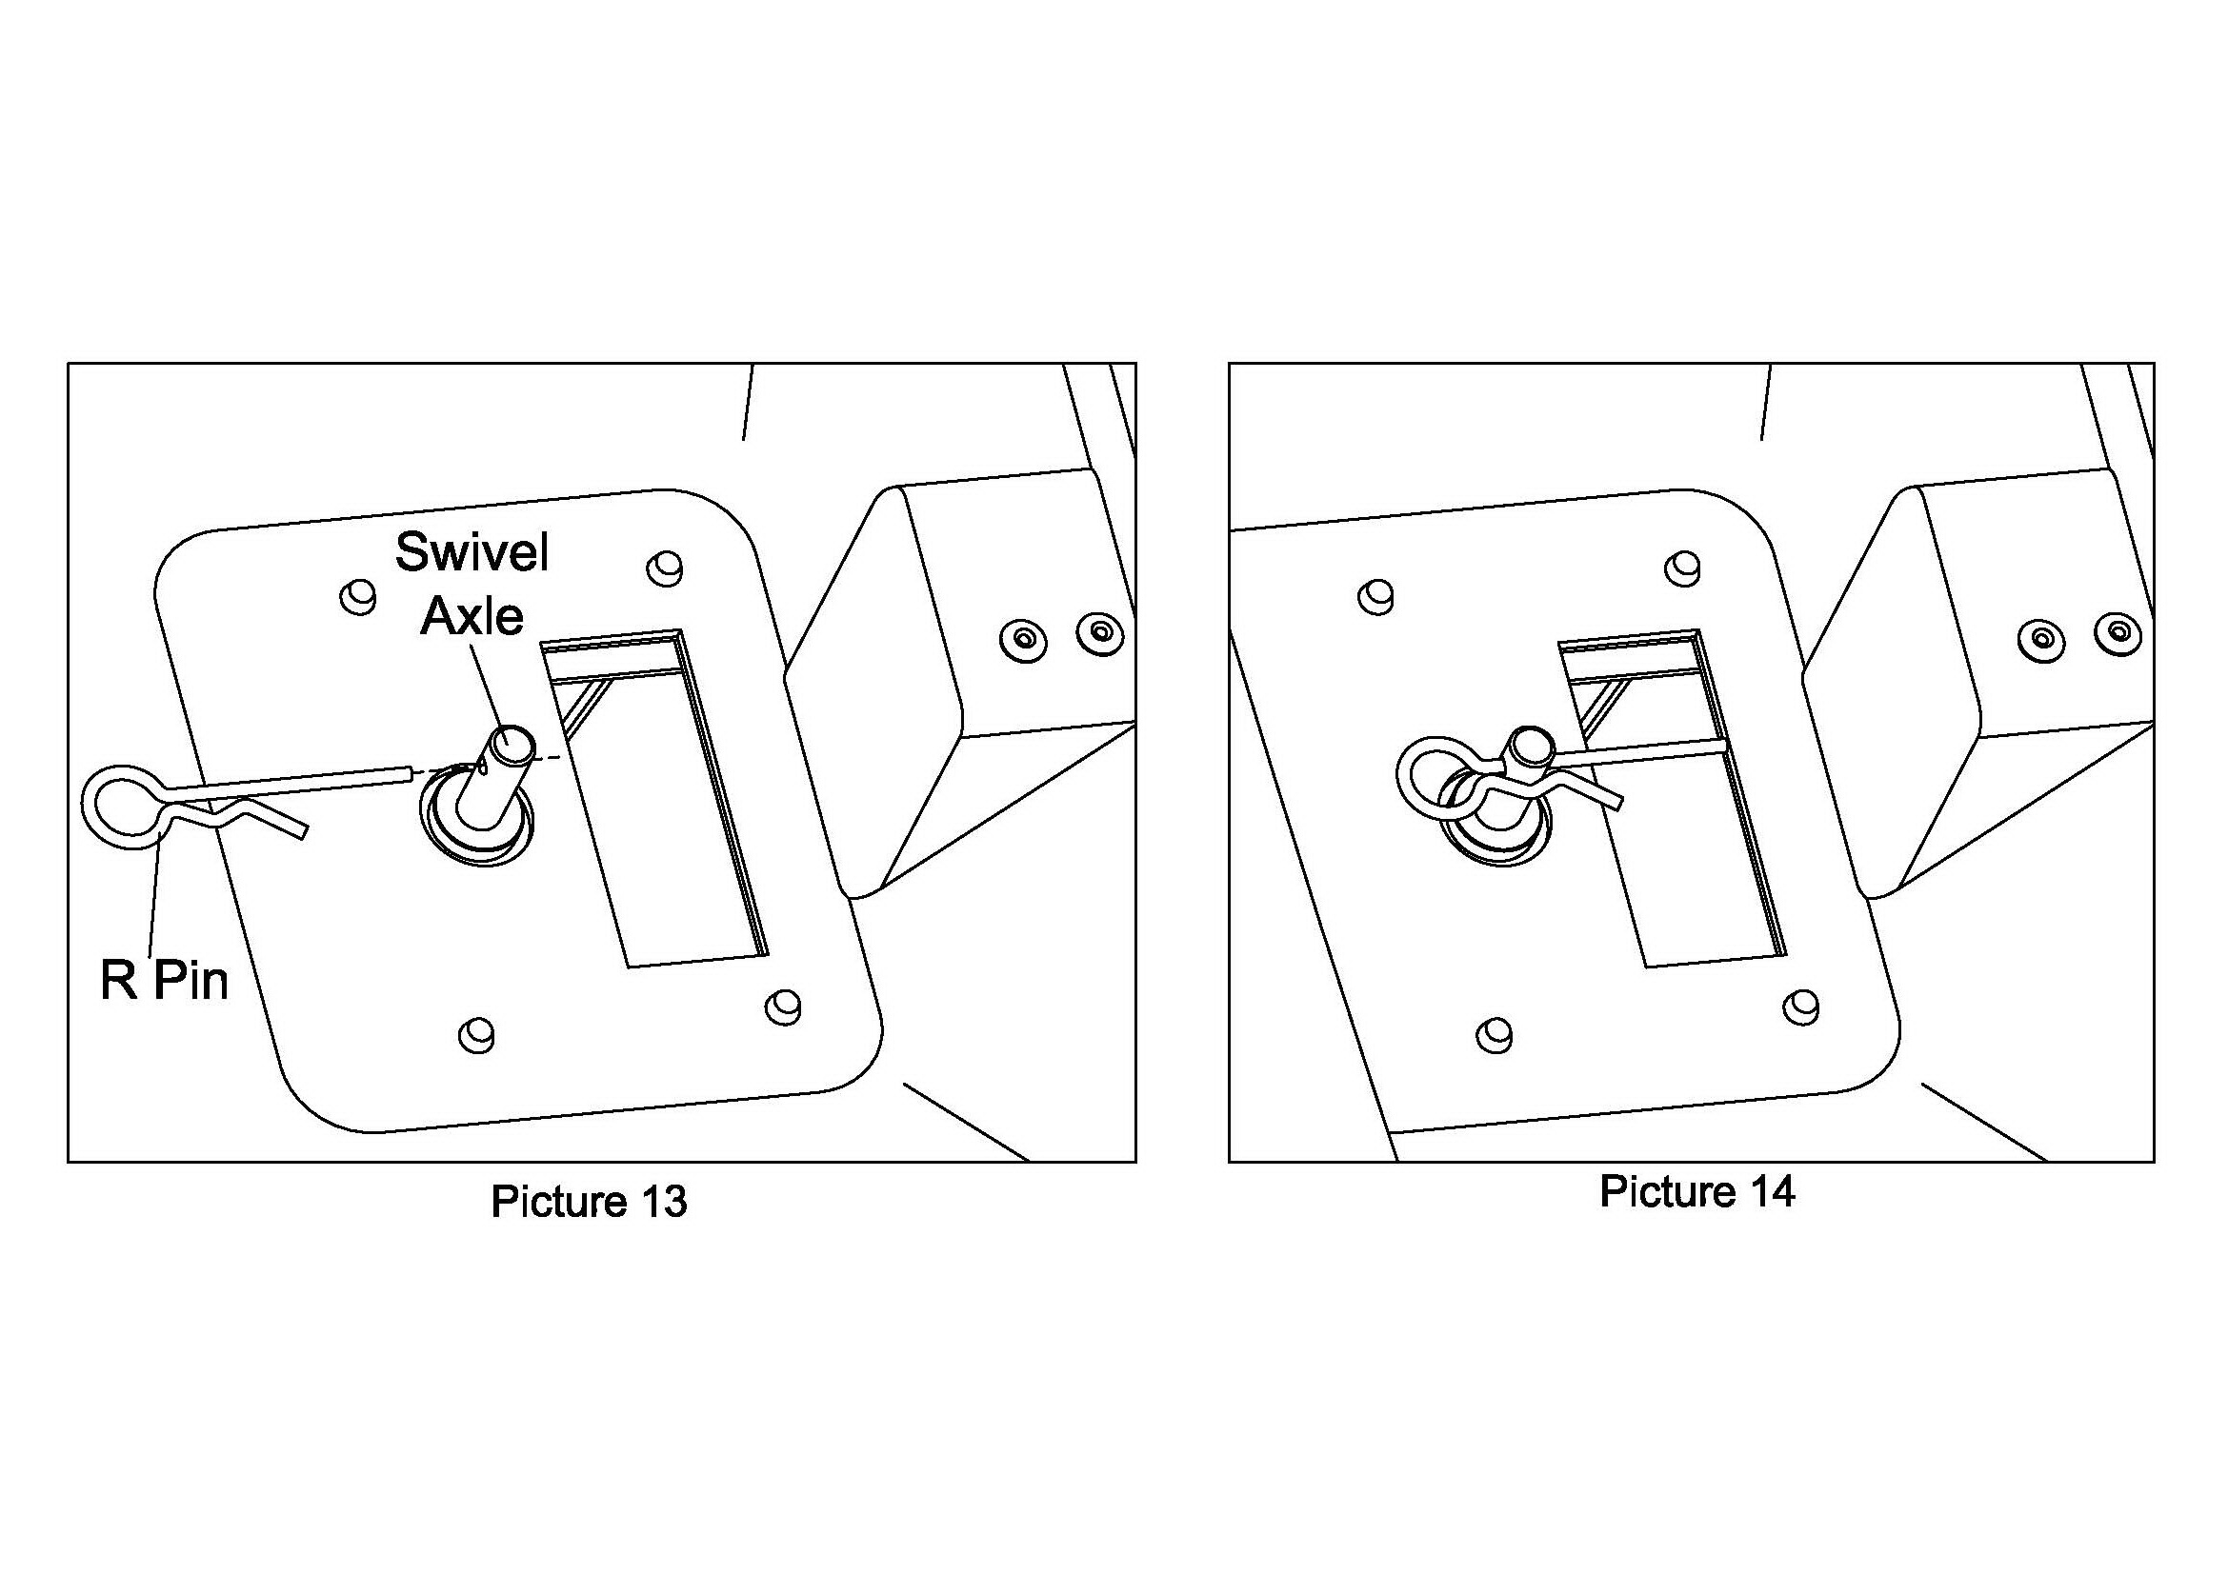

STEP 8: ASSEMBLE THE ADJUSTMENT ROD
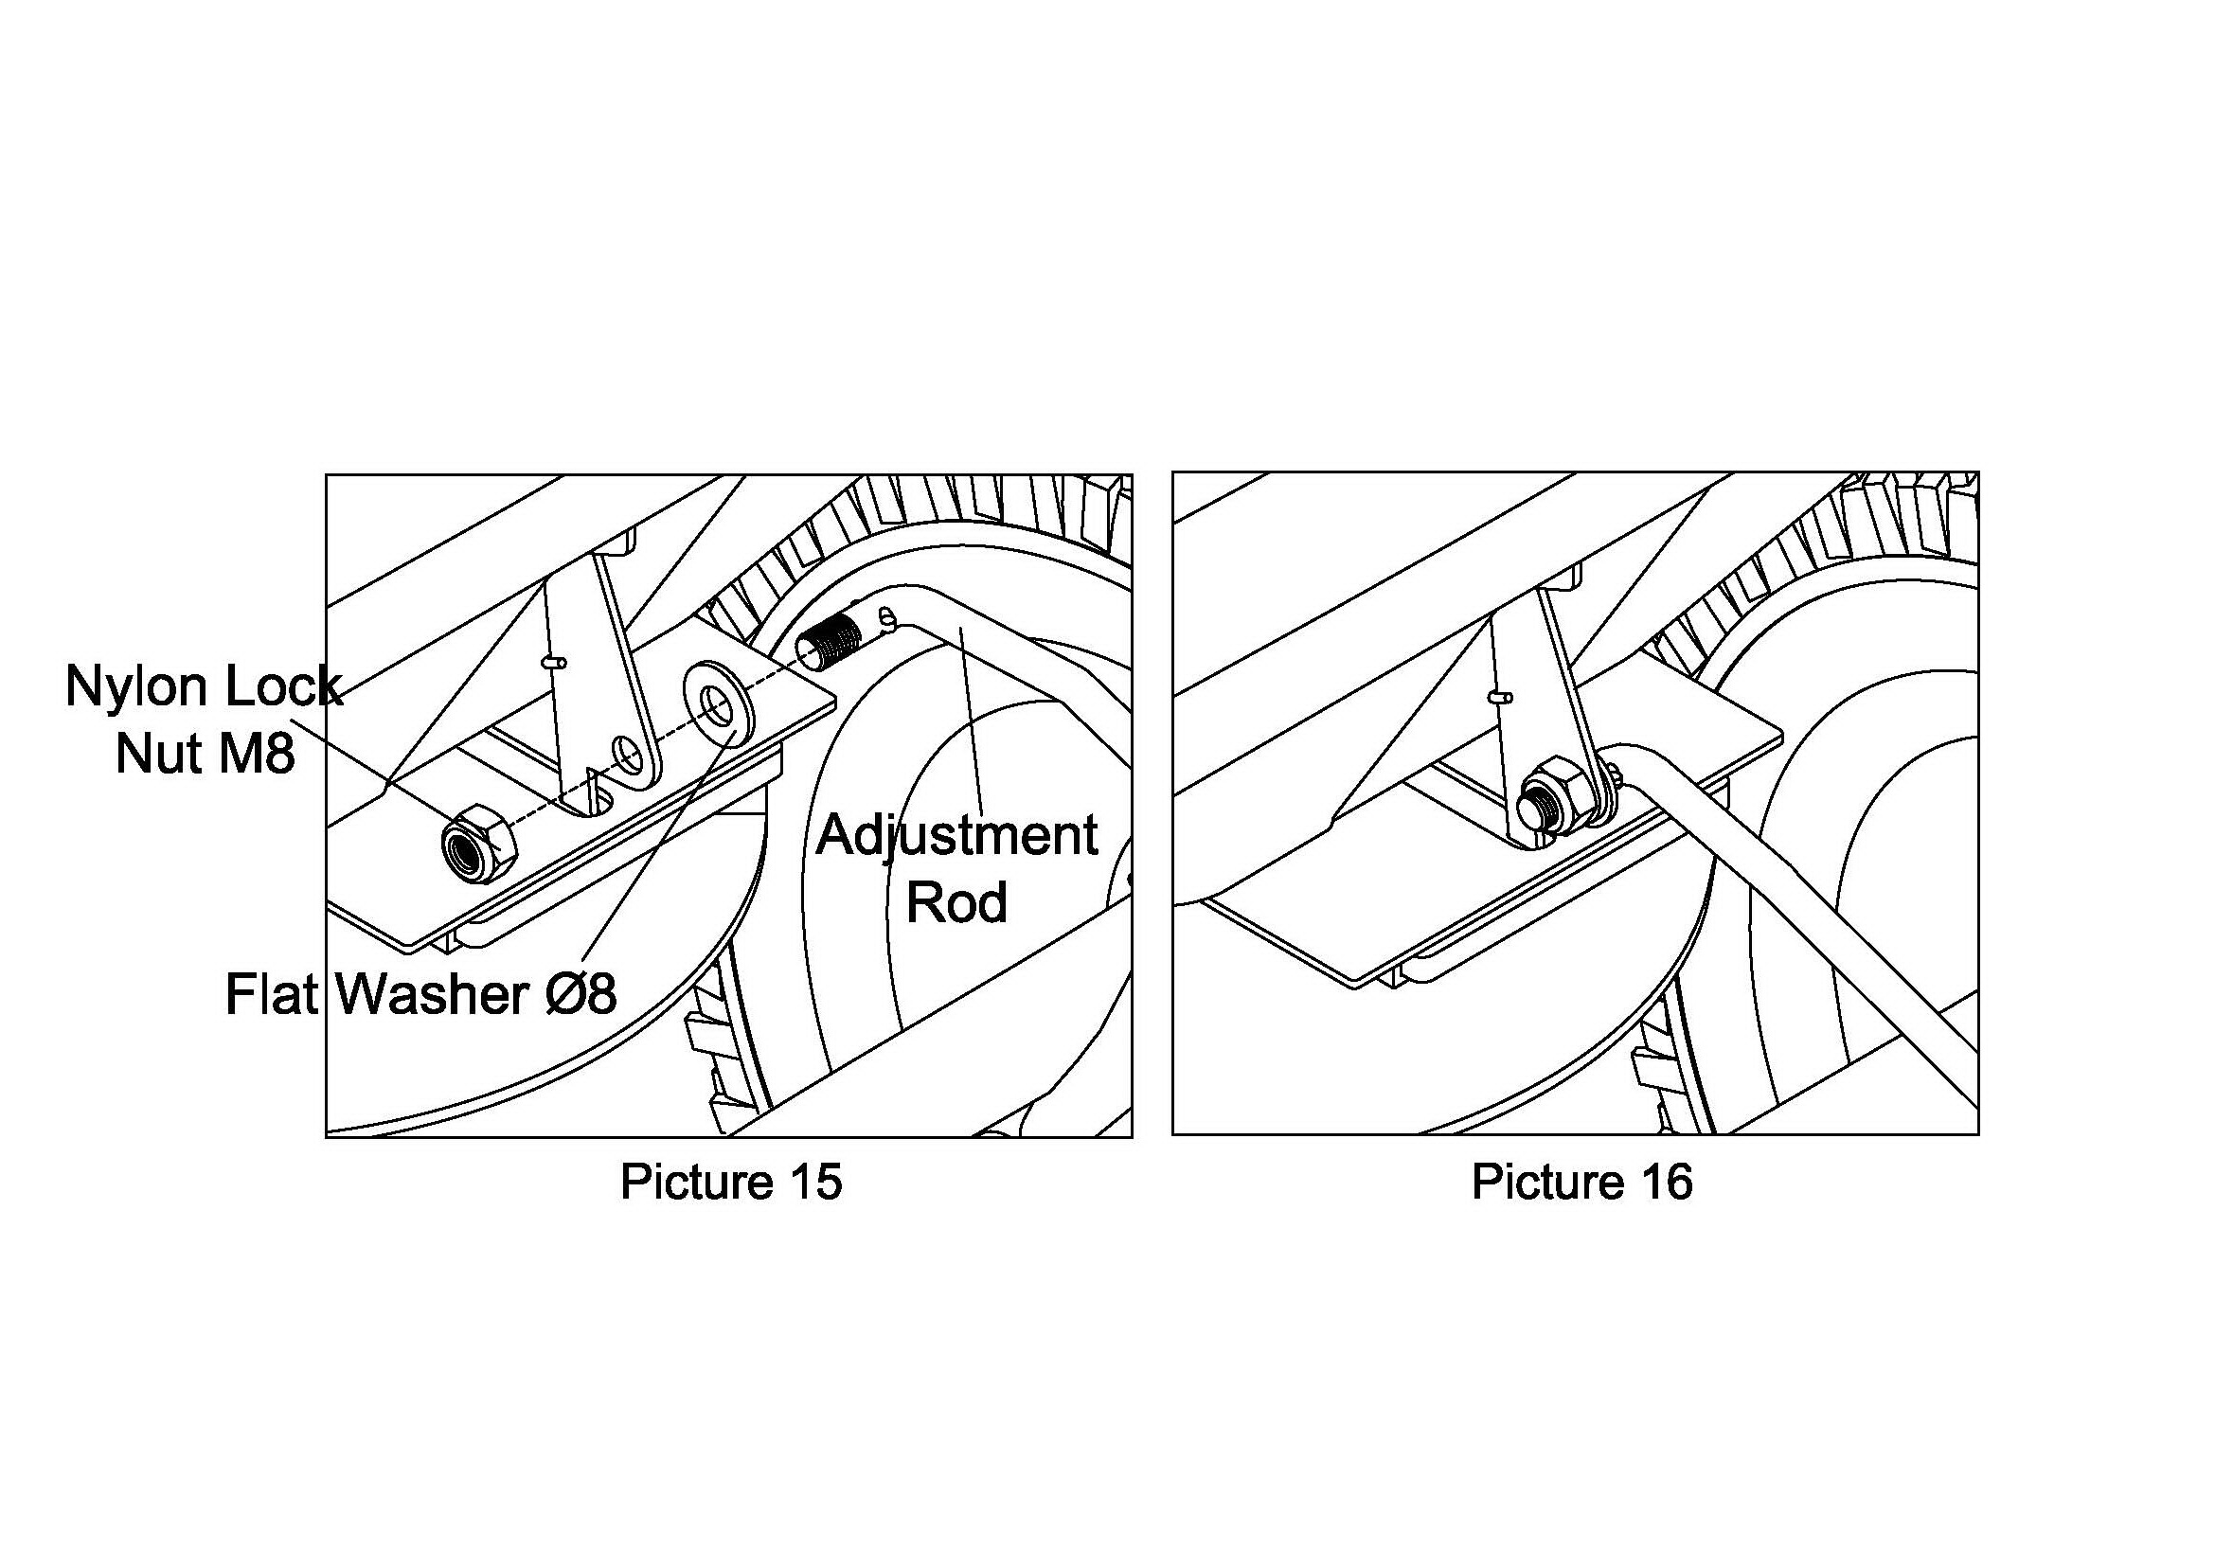
Assemble the Adjustment Rod to the bottom of the Hopper. Insert 1pc of Flat Washer Ø8 to the end of the Adjustment Rod, then insert the adjustment rod to the hole at bottom of hopper, secure the adjustment rod with 1pc Nylon Lock Nut M8. See picture 15 & 16.

NOW, YOUR SPREADER IS FULLY ASSEMBLED.

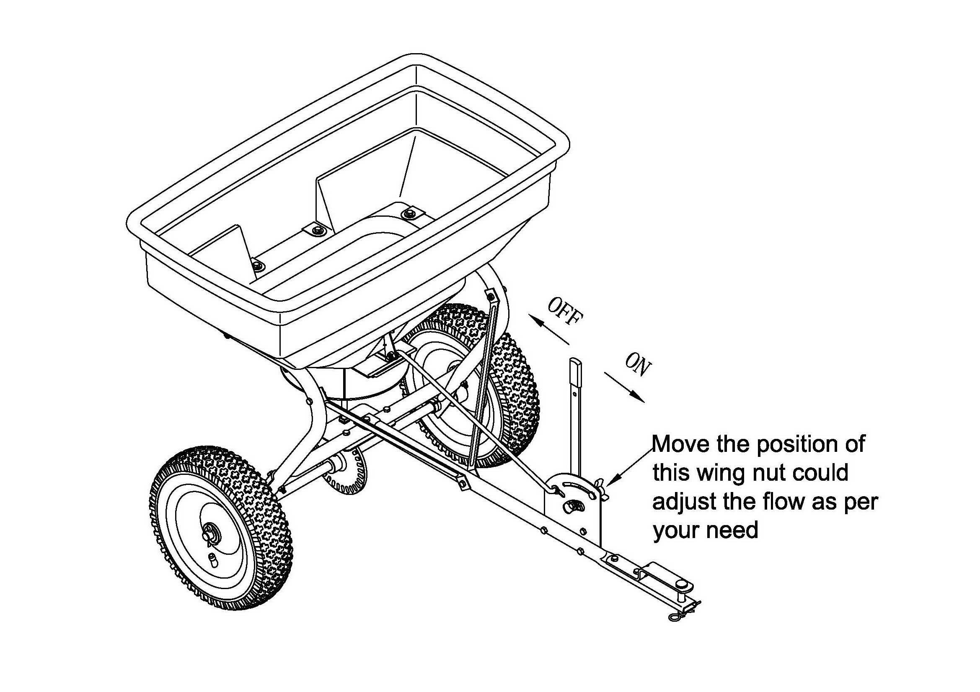

DRAWING

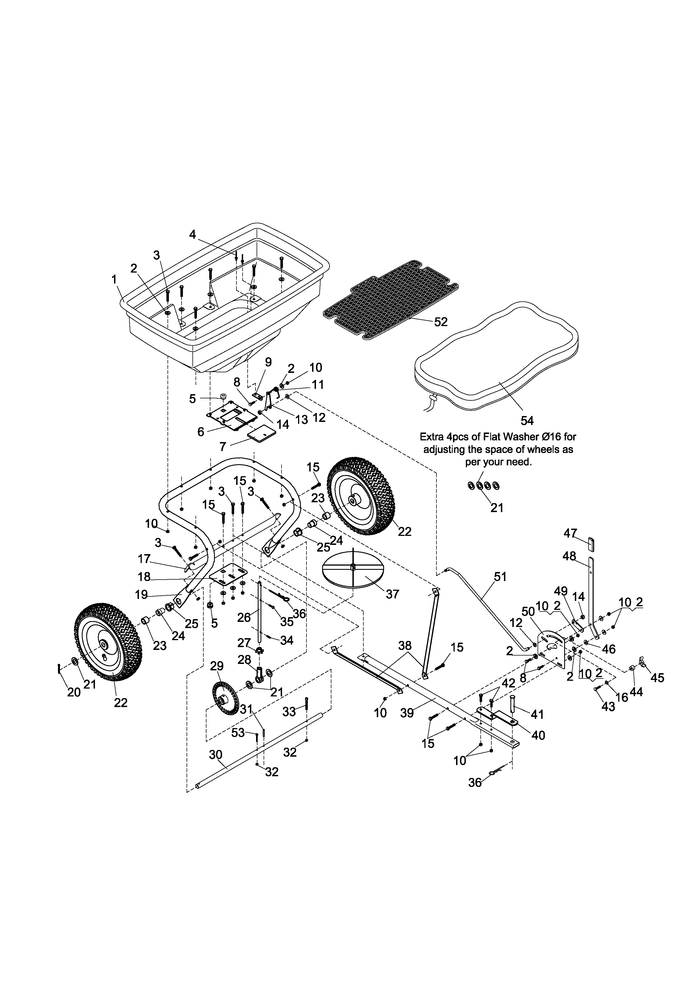

PARTS LIST

Ref# | Description | Qty | Ref# | Description | Qty
1 | Hopper Assembly | 1 | 28 | Swivel Axle Base | 1
2 | Big Flat Washer Ø6 | 16 | 29 | Gear (Driver) | 1
3 | Hex Bolt M6x40 | 9 | 30 | Wheel Axle | 1
4 | Rivet Ø5x10 | 2 | 31 | Pin Ø4x30 | 1
5 | Swivel Axle Bushing | 2 | 32 | Nylon Lock Nut M5 | 2
6 | Fixed Adjustable Plate | 1 | 33 | Inner Hex Bolt M5x45 | 1
7 | Active Adjustable Plate | 1 | 34 | Pin Ø3x16 | 1
8 | Hex Bolt M6x20 | 3 | 35 | Screw M4x20 | 1
9 | Base for Torsion Spring | 1 | 36 | R Pin Ø3 | 2
10 | Nylon Lock Nut M6 | 21 | 37 | Impeller | 1
11 | Torsion Spring | 1 | 38 | Brace Hitch | 2
12 | Flat Washer Ø8 | 2 | 39 | Hitch Tube | 1
13 | Fix Plate for Connecting Rod | 1 | 40 | Hitch Bracket | 1
14 | Nylon Lock Nut ,M8 | 2 | 41 | Pin Ø12x65 | 1
15 | Hex Bolt M6x35 | 7 | 42 | Hex Bolt M6x25 | 2
16 | Teeth Lock Washer Ø8 | 1 | 43 | Carriage Bolt M6x25 | 1
17 | Crossover Tube | 1 | 44 | Spacer | 1
18 | Swivel Axle Fix Plate | 1 | 45 | Wing Nut | 1
19 | Frame Tube Assembly | 1 | 46 | Nylon washer | 1
20 | Cotter Pin Ø5x35 | 1 | 47 | Handle Grip | 1
21 | Flat Washer Ø16 | 7 | 48 | Adjustable Handle | 1
22 | Pneumatic Wheel | 2 | 49 | Connect Rod | 1
23 | Wheel Axle Bushing | 2 | 50 | Gauge Plate | 1
24 | Inner Axle Bushing | 2 | 51 | Adjustment Rod | 1
25 | Outer Axle Bushing | 2 | 52 | Hopper Screen | 1
26 | Swivel Axle | 1 | 53 | Hex Bolt M5 x 40 | 1
27 | Pinion Gear | 1 | 54 | Rain Cover | 1

